Hello dearest supporter!

I hope you are doing well and thank you so so much for all your support this year! You are a fantastic support for our vital work and your help is even more greatly needed than ever before!

This year Project the Project has been very busy ‘projecting our projects’ to new heights thanks to your kind support!

*A quick round up of 2022:*

*We have helped countless families in Tanzania and Uganda during and since Covid 19 with support back to work and school after financial hardships and loss of jobs.*

*We have helped children receive operations and hospital treatment they could otherwise not afford including transport to hospital and follow up aftercare.*

*We have saved women and children from life on the streets, abuse and living on rubbish dumps. We provided training and means of employment as well as medical and psychological assistance. We are now expanding our partnerships and projects in this area.*

*We have also helped thousands of refugee children integrate and catch up with their education and learn the local language of their new settlement so they can get back to school as soon as possible after fleeing their unsafe home country.*

*We have created bespoke training programs and equipment for women who cannot afford sanitary care. Our work has helped them start their own businesses and provide affordable, environmentally friendly sanitary pads to women and girls who used to have to miss school/work during their cycle.*

*We helped supply assistance to Palestinian families in the West Bank so they could rebuild their homes after demolition and raids by the occupying forces.*

*We also helped a huge project in Gaza to screen women for breast cancer and have extended our partnership in this area so we can do more.*

So, we are now building on our current projects and increasing our impact in East Africa and Palestine.

Palestine

Our biggest current project is supporting another round of breast cancer screening in Gaza with Al Alhi Arab Hospital - one of the only remaining medical facilities in the Gaza Strip. This incredible hospital is a beacon of hope, completely funded by charity donations and Gaza is one of the most densely populated regions in the world.

If you donate by December 7th, every penny will be doubled!! Please do help women and consider this as an alternative Christmas gift this year!

Breast cancer kills more women in Gaza than any other form of cancer. Survival rates are just 30-40% compared to 87% in the UK. This is because of the many difficulties the people in Gaza face- a lack of facilities and education mean women rarely gain early diagnosis before the cancer has spread.

Once a woman has been diagnosed, she will only have access to basic treatment in Gaza and will need to obtain a permit from Israeli authorities to leave Gaza for specialist treatment. Only small quantities of medication and limited medical facilities are available in Gaza. These permits are often so delayed or even denied by the Israeli government that it is not possible to save the woman’s life.

*Screening is so simple and so effective. If we can work with women so that they can identify breast cancer early, we can treat it. We need to make screening normal for women and change traditional attitudes. At the moment, too many women die*. Suhaila Tarazi, Director of Al Ahli Arab Hospital, Gaza City

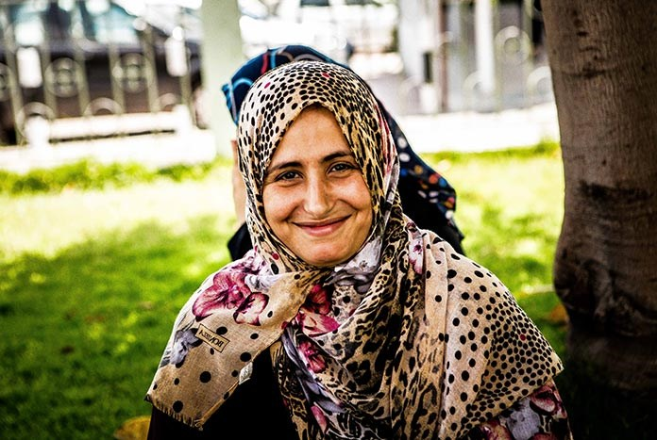**£10** will allow Al Ahli to teach a woman how to identify a lump and introduce her to available treatments. They aim to educate 5,000 women each year.

**£45** will pay for a woman to have a mammogram. Al Ahli aims to screen 3,000 women each year.

**£80** will support a woman who has had breast cancer to come to Al Ahli’s ‘Health, Mind and Body’ group where she will receive psychosocial support, meet other women who have received treatment and learn how to talk about her experiences.

**£120** will support a woman in obtaining a visa to travel to Jerusalem for treatment.

I have met with Gazans who have lost loved ones, simply because their permit to leave the region, often described as an open air prison, has been denied or delayed. We cannot change the political situation, although we can advocate, campaign and make sure as many people as possible understand what is happening. In the meantime, please give what you can to improve the chances of people who need medical treatment in Gaza!

[This](https://reliefweb.int/report/occupied-palestinian-territory/15-years-blockade-and-health-gaza-july-2022) link describes the medical situation in Gaza.

East Africa

In Africa, we are doubling efforts to help some of the poorest women, now even poorer due to recent draughts, to make their own sanitary pads and learn to sell them and run their own small business and improve their life prospects. This helps their families, keeps more children in school and enhances the whole community – women work together and educate other women in health and sanitary care, girls can stay in school during menstruation, children do not have to leave school to help their mother when she has her period and family income is increased.

News of our successful projects has crossed boarders and we are busy advising other communities and connecting with others who wish to replicate our project work. We are always proud to be able to share our knowledge and experiences to help others! Please keep spreading the word about what PTP does!

**You can donate** [**here**](https://projecttheproject.org/contact)

**Bank Transfer:**

**PROJECT THE PROJECT Account number:35286668 Sort code:309897**

*100% donations go to the projects. Helpers and trustees, expenses and resources are funded voluntarily by PTP’s Founder/Director.*

Apologies for the delay brining you this update. Unfortunately, communications are still more limited in the areas we work. I’ll continue to post on our Facebook page [here](https://www.facebook.com/Project-the-Project-1459470637716489) and website [here](https://www.projecttheproject.org/) when we can.

Please help if you can so we can continue our work to bring long term life changing and life saving chances to those without.

You can even donate as you shop online with no cost to you!

<https://www.easyfundraising.org.uk/> and follow instructions to ‘support a cause’ and add Project the Project.

Shops will then donate a small percentage when you buy things!!

Please remember to donate asap as all donations made for our Gaza appeal by December 7th can be matched by generous donors!

Thank you so much for your support!

Very best wishes,

Lucy